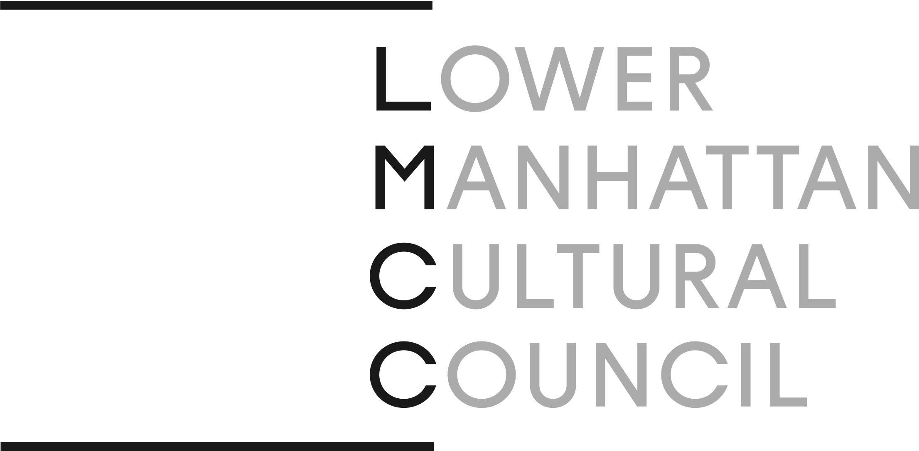

Media Contact FOR IMMEDIATE RELEASE
Carrie Paveglio // Olu & Company
(586) 925-5546 // carrie@olucompany.com

LOWER MANHATTAN CULTURAL COUNCIL PRESENTS 22ND ANNUAL RIVER TO RIVER FESTIVAL, JUNE 9 – 18
The free event series will feature performances and exhibitions across Downtown Manhattan and Governors Island, including dance, live music, installations, and performance art

New York – Lower Manhattan Cultural Council (LMCC) is pleased to announce the 22nd annual River To River Festival, taking place June 9 – 18, 2023. A celebration of dance, music, theater, and visual art, The River To River Festival is Downtown New York’s completely free summer arts festival, celebrating local artists and honoring creative diversity across disciplines. Featuring 12 presentations of live art, performances, and participatory events in public spaces throughout Downtown New York, the 2023 River To River Festival explores themes of reclamation, resistance, and interconnectivity.

Created in the aftermath of 9/11 with the intention to heal and celebrate New Yorkers’ resiliency through the power of art, the River To River Festival is an opportunity for New Yorkers to engage with their local artistic community across disciplines. A champion of independent artmaking since 1973, and the driving force behind this unique festival for over 20 years, the Lower Manhattan Cultural Council has been a proud proponent of the experimentation and exploration that the festival provides to the community. This year’s River To River Festival marks the organization’s 50th anniversary. In honor of the milestone, the 2023 event series features many LMCC alumni working across disciplines, with a strong selection of dance performances in addition to installations, live music and performance events that reflect the interdisciplinary ethos of LMCC.

The 2023 River To River Festival kicks off with the opening reception of El Camino: Stories of Migration, an exhibition of photographs and stories by the multimedia and archival project Nuevayorkinos. Installed in the window galleries along The Seaport’s Fulton Market, the exhibition celebrates stories of Caribbean and Latin American (im)migration to New York City. Following eight intense days of participatory installation and performance taking place across Lower Manhattan and Governor’s Island, River To River will culminate on the evening of June 17 from 6:30 to 8 p.m. with a performance by Guinean multi-instrumentalist Natu Camara and her band of afro-rock and soul musicians in Battery Park City. In the words of Camara: “Get your comfortable shoes ON, my New Yorkers — we are going to sing and dance together by the river!”

Central to this year’s River To River Festival are four dance projects from LMCC’s Extended Life Dance Development Program. Founded in 2013 to extend the lives of ephemeral yet essential works of dance, the Extended Life initiative advances the creative lives of dancers and choreographers through a framework of institutional collaboration. Created and managed by LMCC at The Arts Center at Governors Island, this unique residency enables mid-career choreographers to expand and experiment with their works, presenting in site specific environments and giving artists the opportunity to develop strong, collaborative partnerships with local performers and national presenters. This year’s Extended Life artists are AUNTS, Antonio Ramos, Andros Zins-Browne, Molly Lieber and Eleanor Smith.

This year’s festival also includes the New York premiere of the collaborative performance project Lotto Royale. Originally conceived by the artist Camila Malenchini in conjunction with the Berlin-based artist collective T.E.N.T, Lotto Royale is a two-day program of one-on-one performances in public spaces, in which audience members are paired with performing artists via lottery system.

Other Festival events include a weekend-long participatory installation by the artist Marta Blair, a walking tour uncovering Manhattan’s historic Little Syria neighborhood by the Washington Street Historical Society, artist-in-residence open studios, and a special workshop presentation by Amelia Winger-Bearskin titled Talk To Me About Water in the galleries at The Arts Center at Governors Island.

“We are thrilled to bring artists’ vision and energy to different sites across Lower Manhattan foreveryone to enjoy,” said Jess Van Nostrand, LMCC’s Director of Exhibitions and Public Programs. “We look forward to seeing visitors of all ages celebrate creativity with us!”

“Totally free and open to all, The River To River Festival is a celebration of what is possible when artistic creativity, cultural institutions, civic bodies and corporate entities come together in mutual support,” said LMCC President Craig T. Peterson. “We recognize the importance of this ecosystem to the health, vibrancy and future of our city.”

Dates, times and locations are subject to change. Be sure to visit the LMCC website for up-to-date information. Please note that all events are free, but due to limited capacity some events require advance registration – RSVPs open June 1, 2023.

ABOUT RIVER TO RIVER FESTIVAL
The annual River To River Festival presents live art and installation in exceptional public spaces throughout downtown New York. Free and open to the public, the River To River Festival celebrates artistic and creative diversity across disciplines, partnering with leading institutions in Lower Manhattan to celebrate the city as a site of human connection and creative exploration.

RIVER TO RIVER 2023 PARTNERS
Leadership Support
Mellon Foundation
Dance Reflections by Van Cleef & Arpels

Major Support
Battery Park City Authority
Goethe Institut
The Howard Hughes Corporation

Friends of The Festival
ConEdison
The Howard Gilman Foundation
NYC Department of Cultural Affairs

Presenting Partners
Allies in Arts
The Battery Conservancy
The Clemente Soto Vélez Cultural & Educational Center
Cove Property Group and BentallGreenOak
Lotto Royale
The Trust for Governors Island & Creative Time
Washington Street Historical Society

ABOUT LMCC
Founded in 1973 by Flory Barnett with support from David Rockefeller, Sr. and Chase Manhattan Bank, New York State Council on the Arts (NYSCA), and other local business and civic leaders, Lower Manhattan Cultural Council (LMCC) was built on the premise that artists were pillars of resilience and inspiration and therefore vital to New York City. For almost five decades, LMCC has advanced their vision to serve, connect, and make space for artists and communities in NYC through programs that deepen artists' creative practice and afford them opportunities to share their process and work with local communities.

lmcc.net
Facebook: facebook.com/LMCCNYC
Twitter: @LMCC
Instagram: @LMCC_NYC

